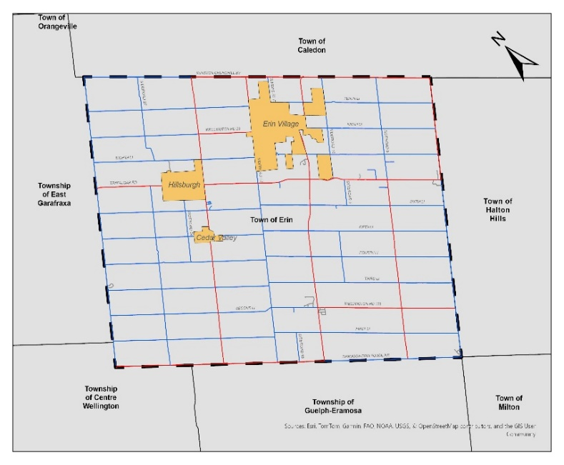
To strategically prepare for growth and enhance the Town’s existing transportation network, the Town of Erin has retained 30 Forensic Engineering (30FE) to undertake the development of the Town’s first Transportation Master Plan (TMP) study. The TMP will be a strategic policy document that will serve as a road map for short, medium, and long-range transportation infrastructure investments, as well as integrated multi-modal transportation planning, to meet the demands up to the 2055 horizon year.
Study Area/ Location
The Process
The TMP will be developed in accordance with the Provincial Environmental Assessment (EA) Act, following the Approach 1 as outlined in the 2023 Municipal Class Environmental Assessment (MCEA) document. The TMP will cover Phase 1, Problem and Opportunity, and Phase 2, Alternative Solutions, of the MCEA process and facilitate streamlining and implementation of recommended capital works.
Have your say
An important part of this study is consultation with the public, stakeholders, and the Town’s agency partners. 30FE wants to hear from you about the issues and opportunities that you see for the Town’s Transportation System to the horizon year of 2055.
At any time during this study, you can provide comments, questions, and concerns to the project team. We will also organize Public and Stakeholder engagement events to present an overview of the study and existing conditions while outlining alternatives, evaluation, and study recommendations.
The project team will host two Public Information Centres (PIC) to gather public input and present the findings of the study. Details of the first Public Information Centre are as follows.
Public Information Centre 1
The project team will be hosting a drop-in style event to introduce the project, share public feedback gathered to date and work completed thus far as part of the initial phase of the project. This event will also provide an opportunity for members of the public to share their opinions on the current transportation network as well as on how the Town should plan for a future transportation network that will accommodate the growth planned for 2055.
Event Details:
- Location: Erin Legion - 12 Dundas St E, Erin, ON N0B 1T0
- Date: February 26, 2025
- Time: 5:00 p.m. – 7:00 P.M.
Accessible formats and communication support are available upon request. The Town of Erin is committed to accessibility for people with disabilities. Please contact Danial.Tunio@erin.ca if you have an accessible accommodation request.
Privacy Statement
Information is collected under the authority of the the Municipal Freedom of Information and Protection of Privacy. If you require additional information, please visit Town of Erin Freedom of Information.
Contact Us
For further information or to share your valuable input, please contact the study team:

Mehemed Delibasic, P.Eng.  Consultant Project Manager  -30- Forensic Engineering  Phone: (416) 678-0788  mdelibasic@30fe.com | Danial Tunio, C. Tech., rcji  Engineering Technologist  Town of Erin  Phone: (519) 855-4407 ext. 251  Danial.Tunio@erin.ca

